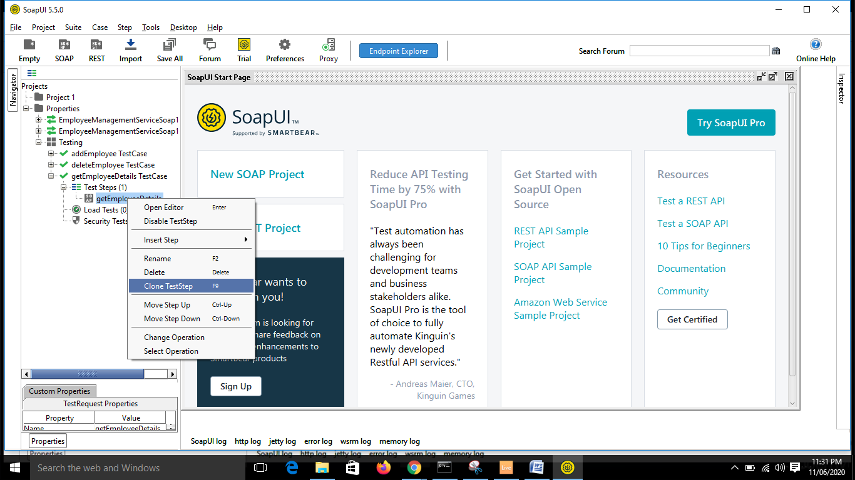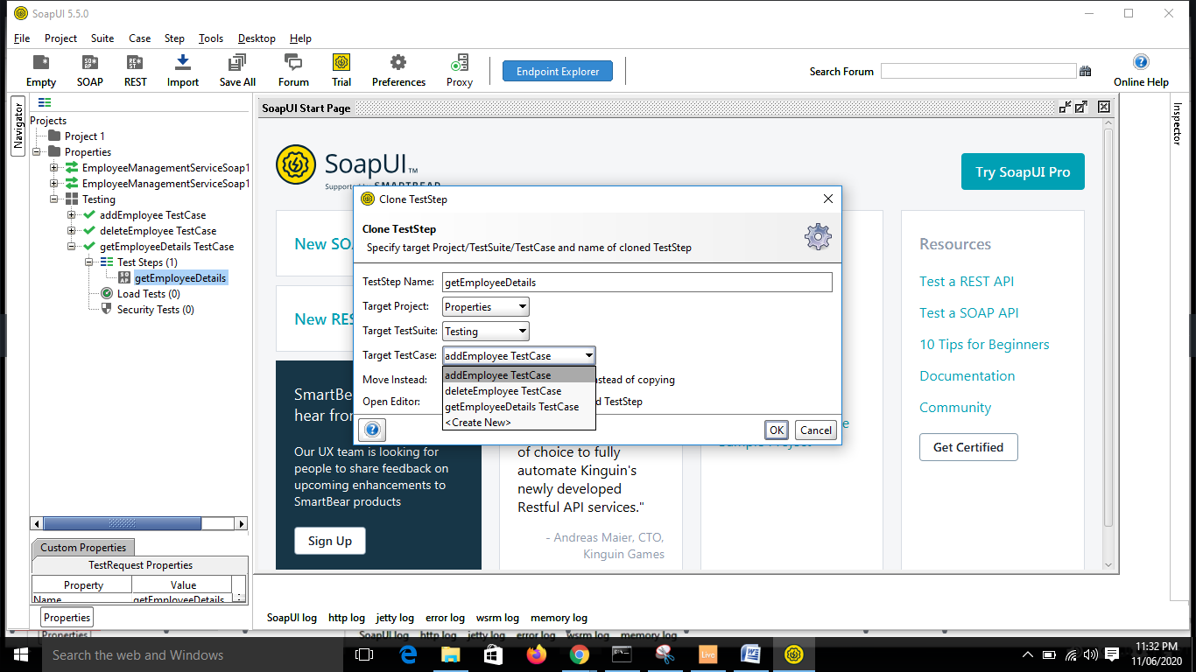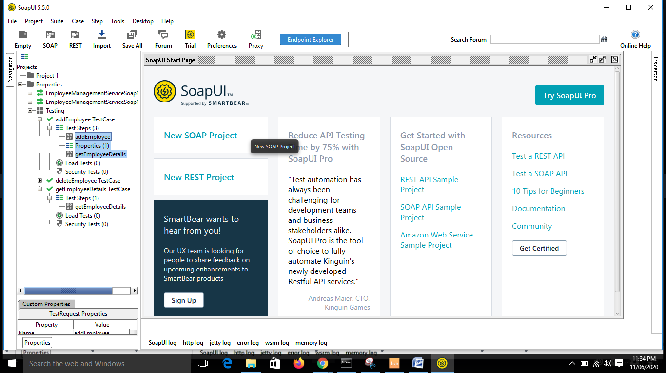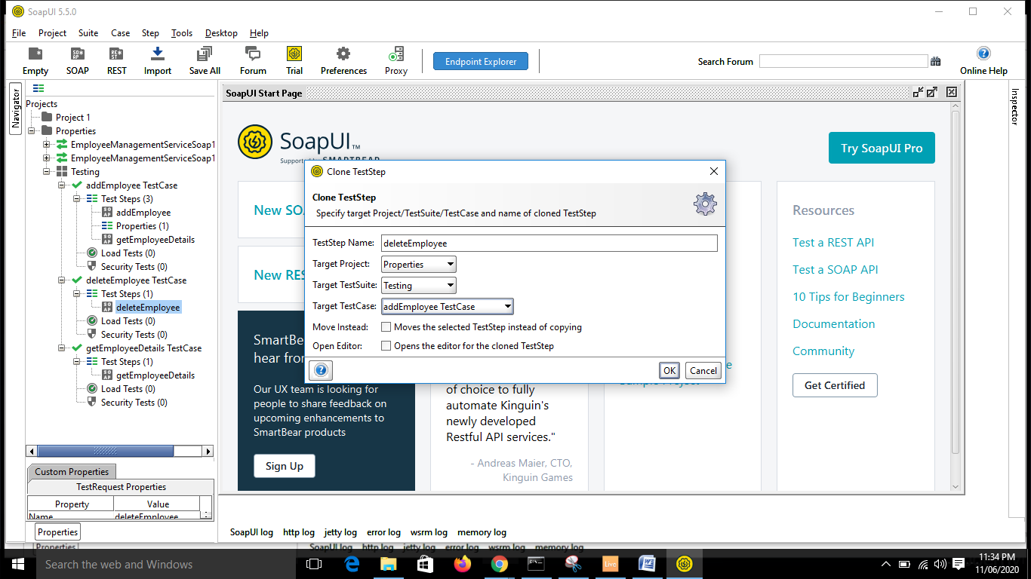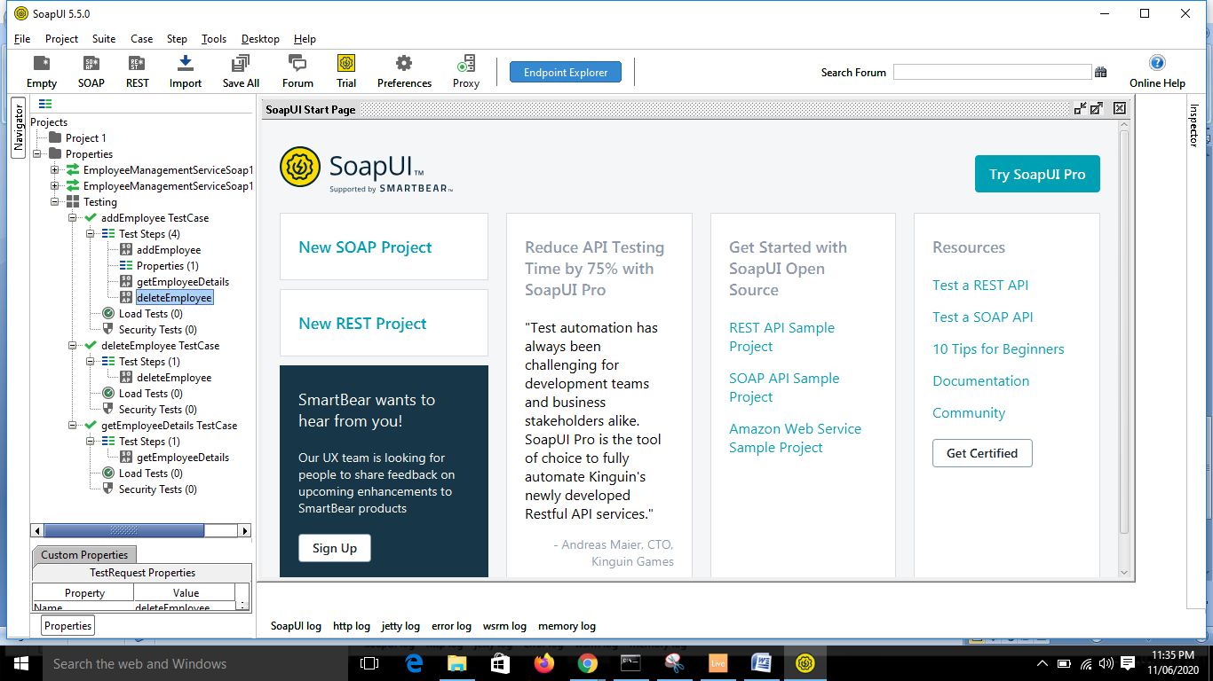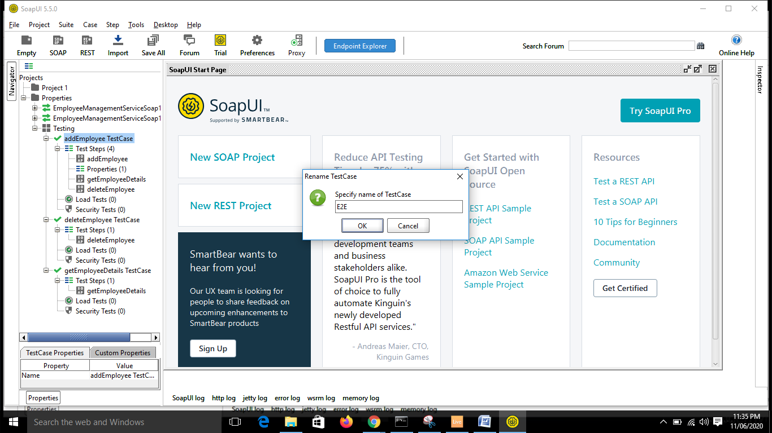

* Suppose we need to get the value from getEmployeeDetails and place in delete employee:

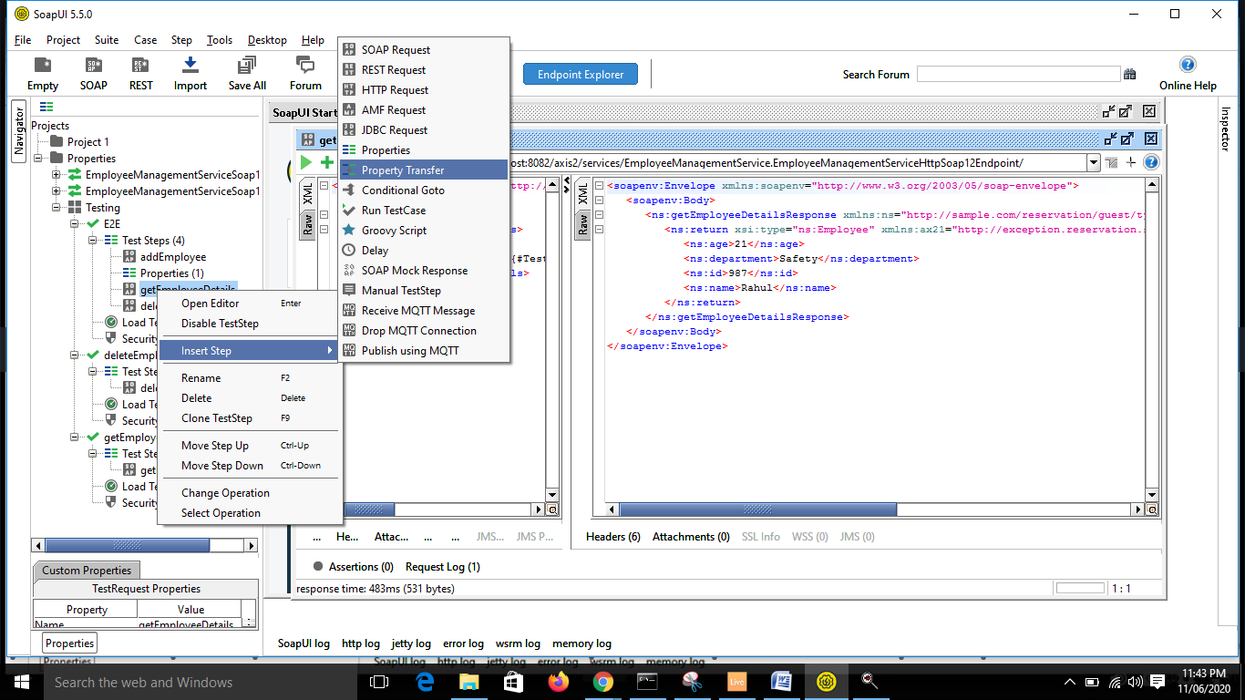

* Under Testing create blank name “namePropertyTransfer”

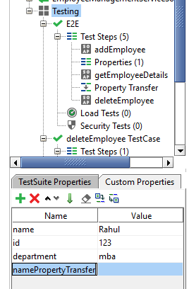

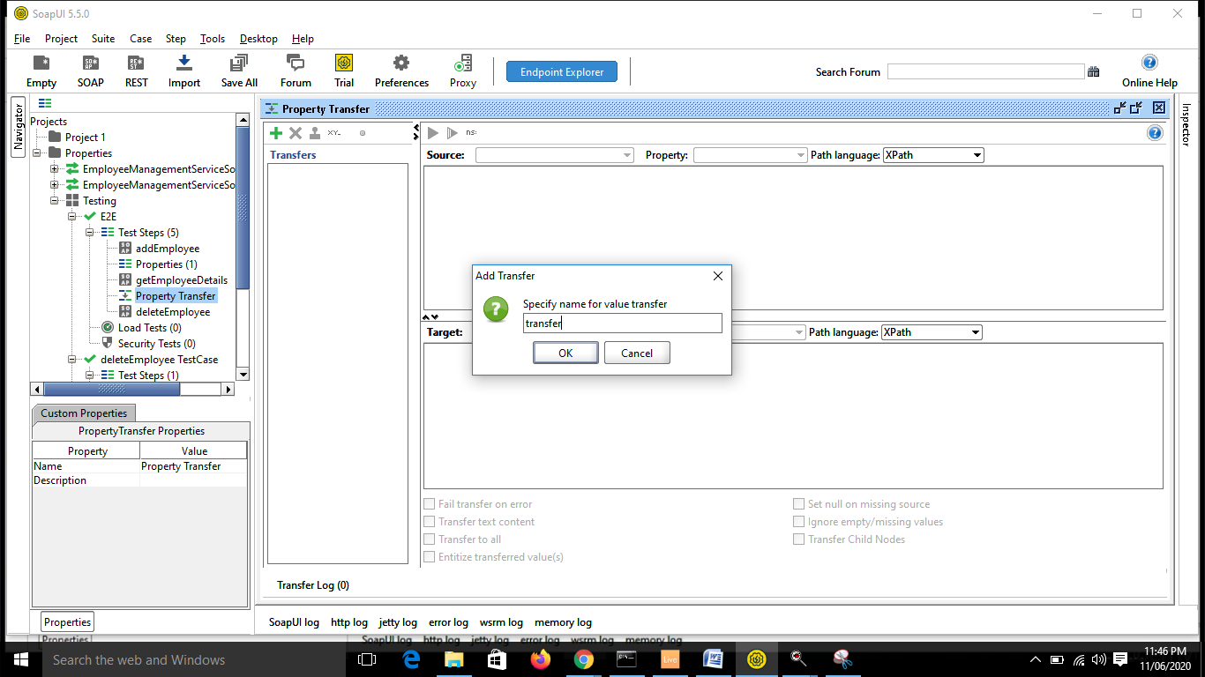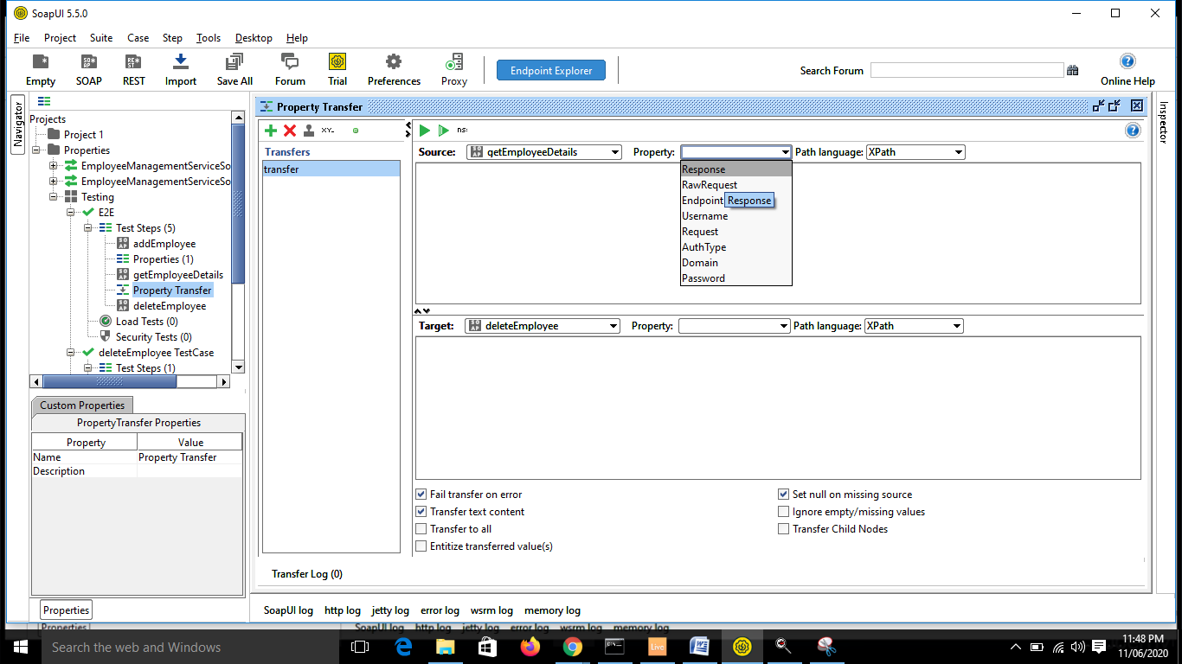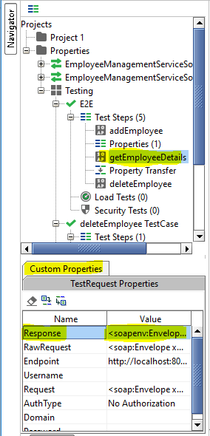

* You cannot create property in Test Step level.

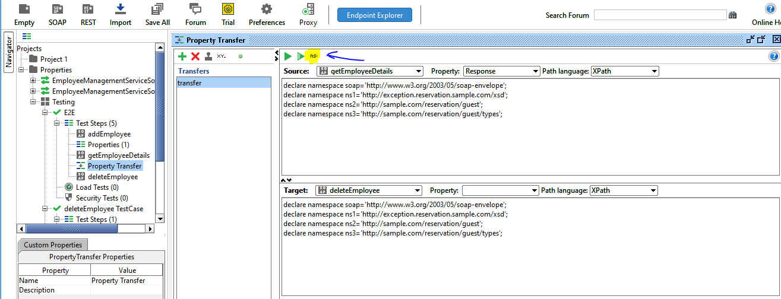

* Now edit the Name Space details:
* Check what is the prefix in the xml tags. Its ns.

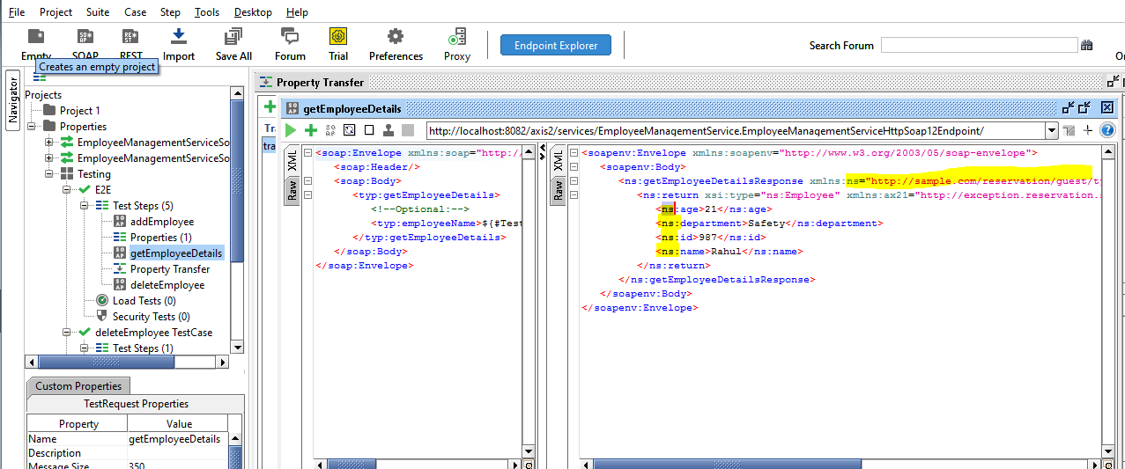

* Copy this:

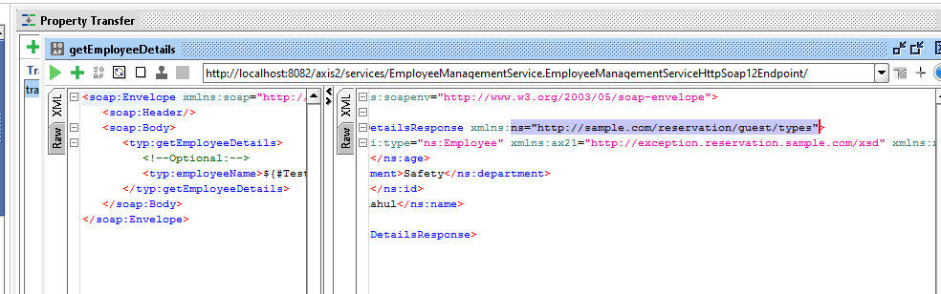

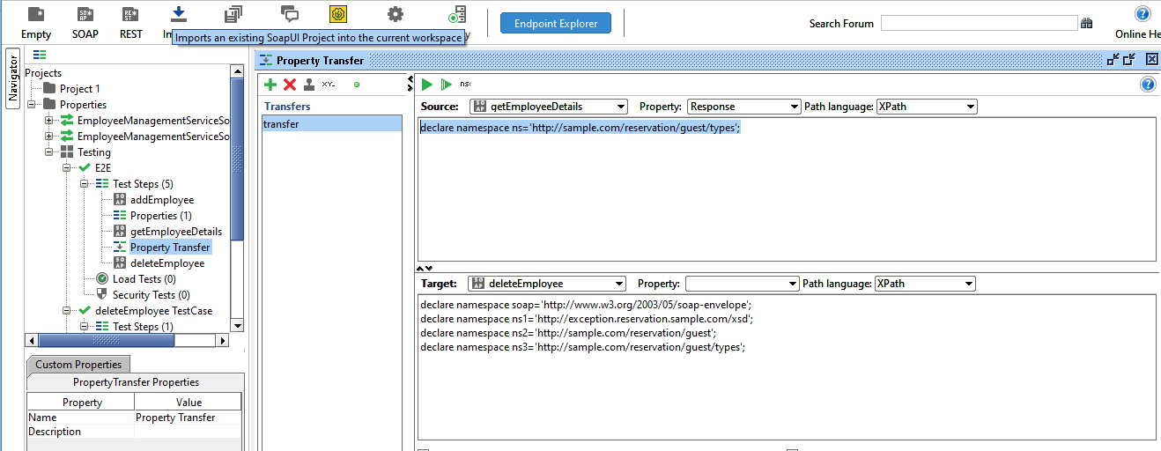

9:39

* ns means name space.
* GET employee details:

<soapenv:Envelope xmlns:soapenv="http://www.w3.org/2003/05/soap-envelope">

<soapenv:Body>

<ns:getEmployeeDetailsResponse xmlns:ns="http://sample.com/reservation/guest/types">

<ns:return xsi:type="ns:Employee" xmlns:ax21="http://exception.reservation.sample.com/xsd" xmlns:xsi="http://www.w3.org/2001/XMLSchema-instance">

<ns:age>21</ns:age>

<ns:department>Safety</ns:department>

<ns:id>987</ns:id>

<ns:name>Rahul</ns:name>

</ns:return>

</ns:getEmployeeDetailsResponse>

</soapenv:Body>

</soapenv:Envelope>

* Write the xpath for the name field.

//ns:getEmployeeDetailsResponse/ns:return/ns:name/text()

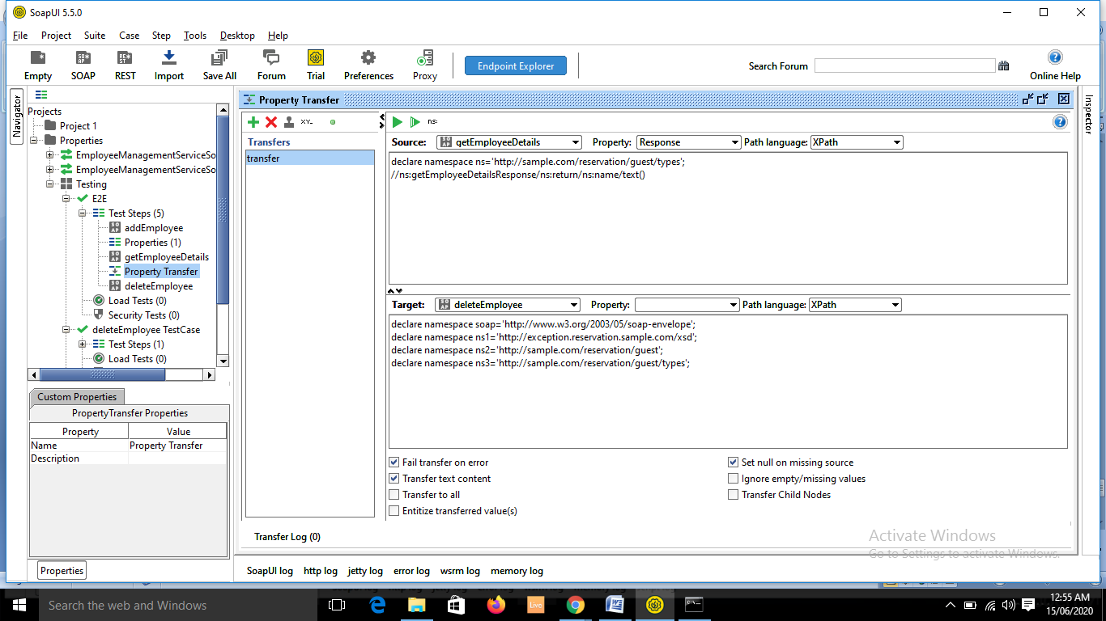

* Now go to delete part and declare the ns and XPath

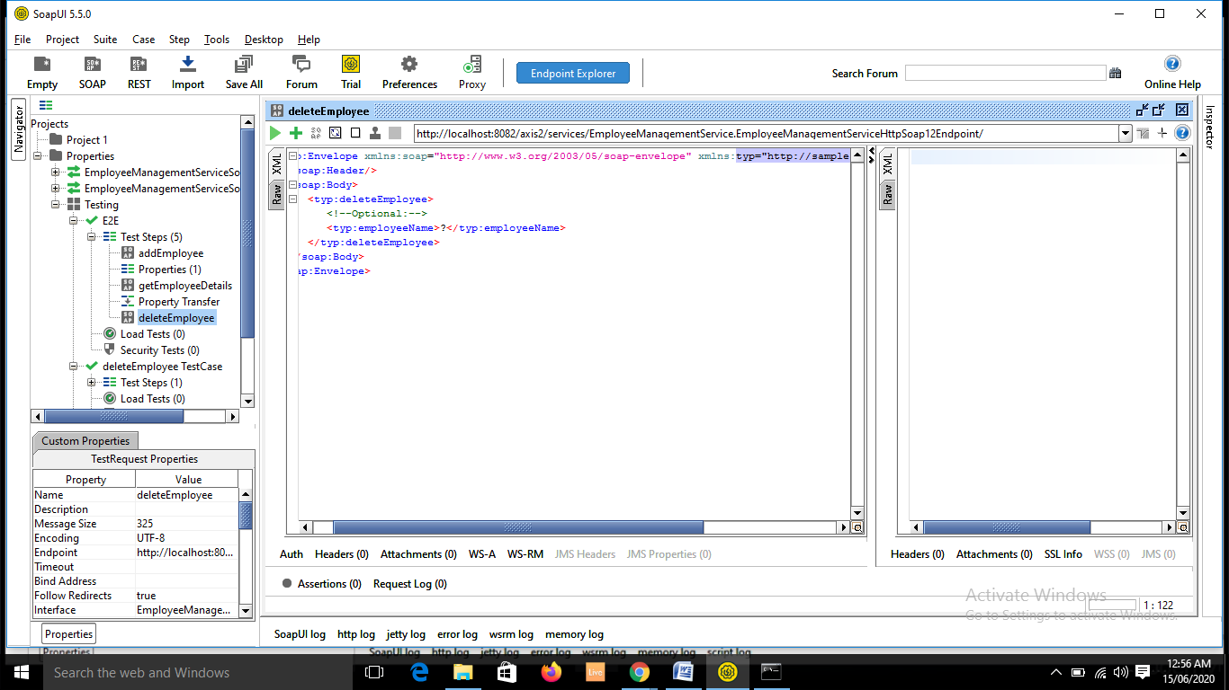

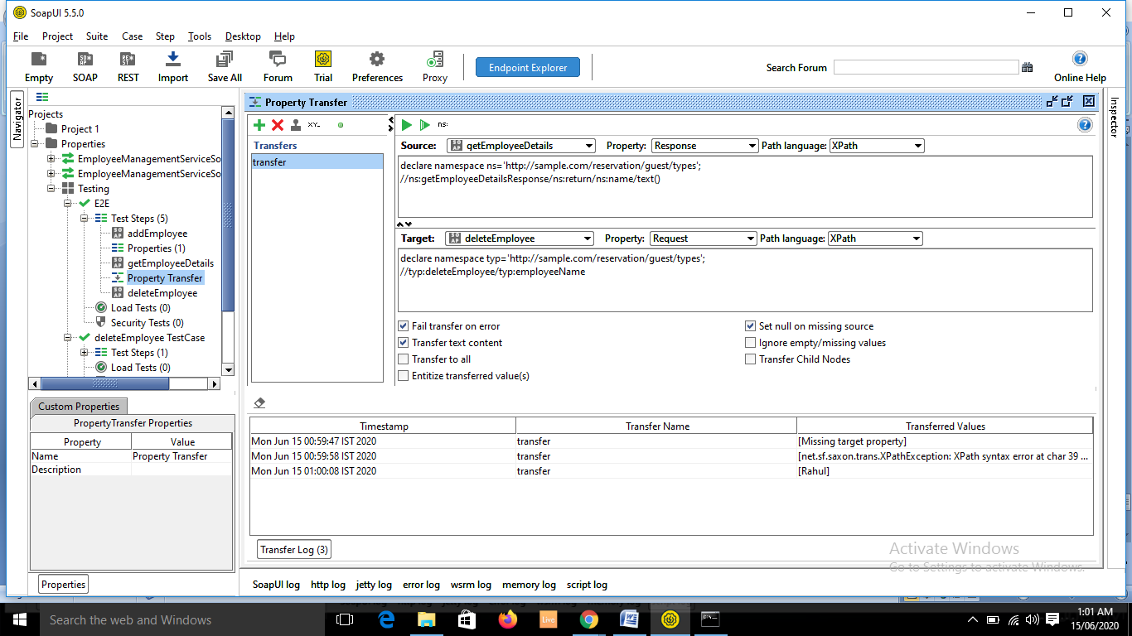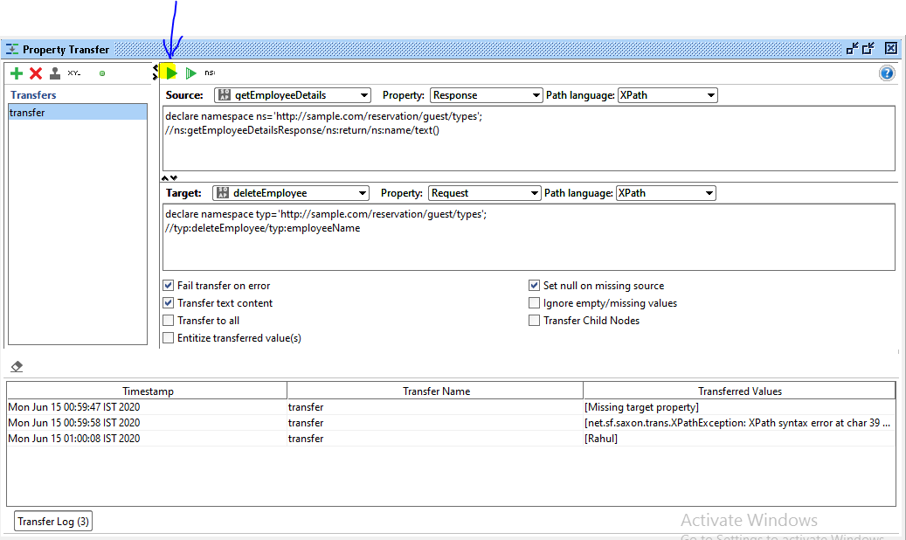

* It will autopopulate the name:

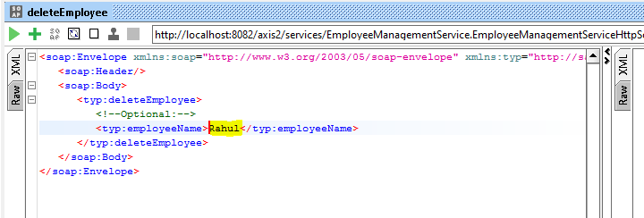

* Example, when Property Transfer will be used.

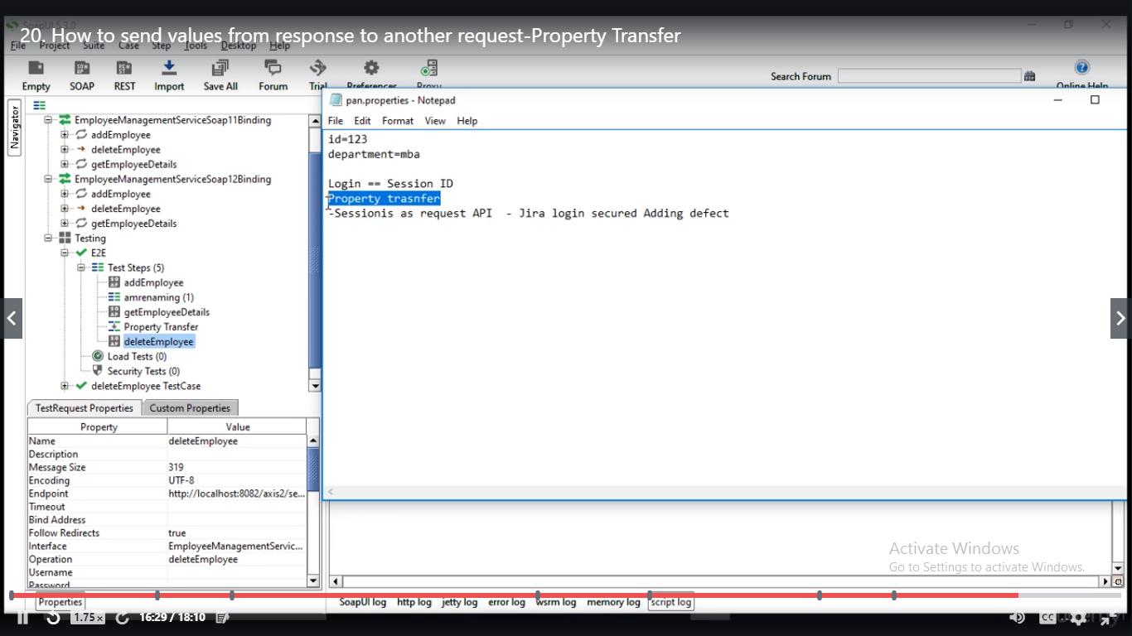

* Run the test case:

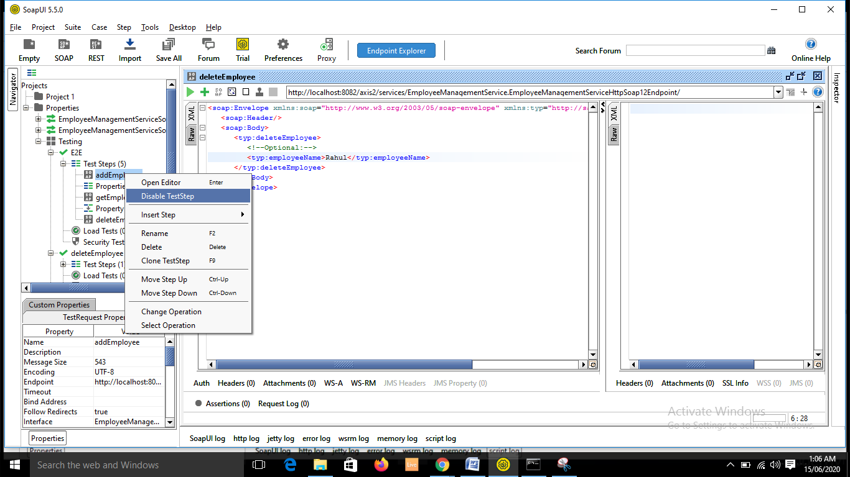

* Double click on Testing suite

